# For the given JSON iterate over all for loops (for, for in, for of, forEach).

**JSON given in class :**

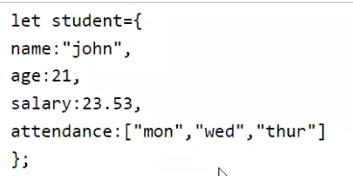

1. **For loop** can be used to iterate array

for(let i=0;i<student.attendance.length;i++)

    console.log(student.attendance[i]);

//output: mon

tue

wed

1. **For In loop** – preferred for iterating JSON object

 for(let key in student)

    console.log(student[key]);

//output: john

21

12.3

['mon', 'tue', 'aed']

1. **For of** loop can be used to iterate the array

 for(let val in student.attendance)

console.log(val);

//output: mon

tue

wed

1. ForEach loop

 student.attendance.forEach(element => {

       console.log(element);

   });

//output: mon

tue

wed

# Create your own resume data in JSON format

let resume =

{

    name:"Philomina",

    email:"philomina.jeni@gmail.com",

    objective:"Graduate in Computer Science Engineering.Willing to enhance my knowledge about new and emerging trends in a challenging workplace that welcomes innovative ideas and offers growth opportunities and a positive environment for accomplishing projects.",

    location:"Chennai",

    qualification :

{

        "10th": "98%",

        "12th":"92.5%",

        "UG":"8.2 CGPA"

    },

    experience:

{

        "2019-2021":"CTS"

    },

    skills:["JS","HTML","CSS","C","C# basics","Python basics","ReactJS","Node JS" ],

    Languages: ["English","Tamil"],

    hobbies:["lisening songs","Gardening"],

    projects:["Web apps"]

}